**Big Data in Supply Chain Management (SCM) 📊🚚**

By Binoy Patra

Big Data is revolutionizing Supply Chain Management by enabling smarter decisions, real-time tracking, risk management, and enhanced efficiency. From forecasting demand to improving last-mile delivery, big data analytics is a game-changer for modern supply chains.

**🔍 How Big Data Analytics Works in Supply Chain**

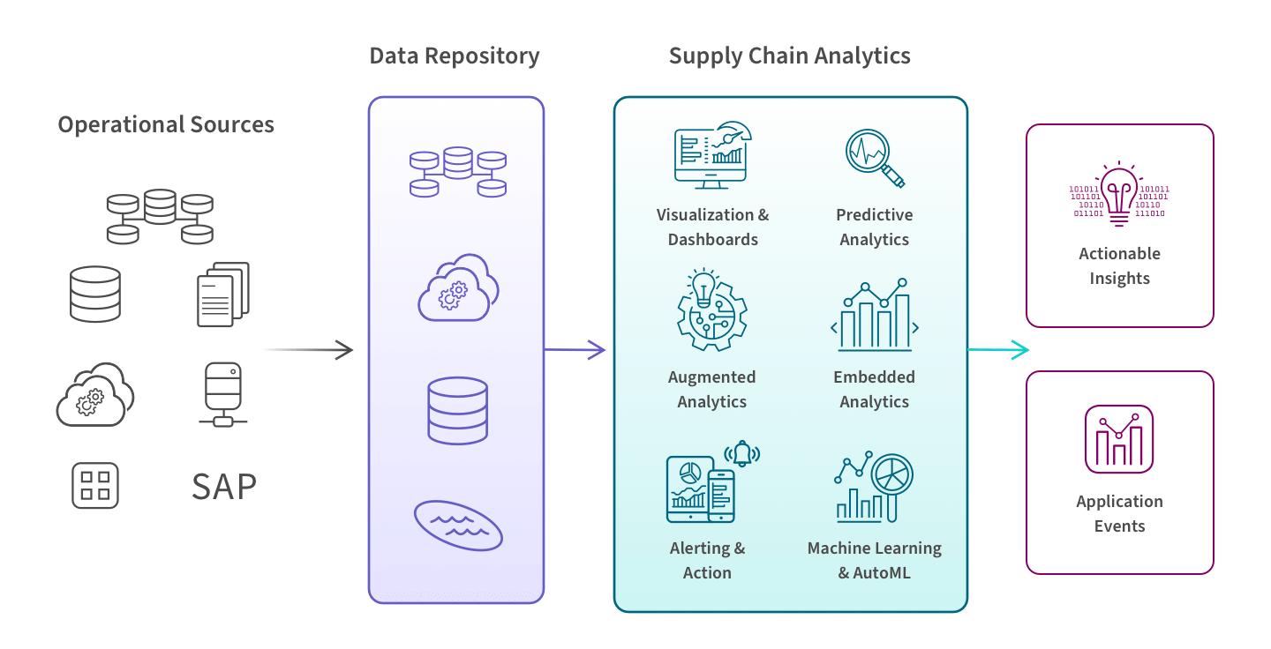

Every step in the supply chain—from procurement and inventory to fulfillment and transportation—generates data. This data is collected from **operational systems** (like SAP or WMS), and also from **external sources** such as suppliers, carriers, and third-party merchants.

📥 **Step 1: Data Collection & Storage**  
All this data is extracted, cleaned, and consolidated into a centralized **data repository**—a cloud-based **data lake** or **warehouse**—giving organizations a complete and unified view of their logistics network.

📊 **Step 2: Analytics & Intelligence**  
Modern **supply chain analytics tools** take over from here. These tools help teams:

* 📈 Build dashboards & interactive reports
* 🔮 Run predictive analytics (e.g., forecast returns, demand)
* ⚙️ Use augmented analytics to uncover patterns
* 🤖 Apply AutoML & machine learning for smarter, real-time decisions
* 🚨 Set up alerts and triggers based on specific supply chain events

📤 **Step 3: Actionable Outcomes**  
All this leads to **actionable insights** and **automated workflows**, enabling data-driven decisions that directly impact operations—from rebalancing inventory to rerouting shipments in real-time.

**🔍 Key Applications of Big Data in SCM**

**1. Demand Forecasting 📈**

Big Data allows companies to analyze sales history, customer behaviour, seasonality, and external factors (like weather and market trends) to make highly accurate demand forecasts.  
✅ Prevents stockouts  
✅ Reduces overstock and carrying costs  
**Example**: Retailers like Walmart and Amazon analyze billions of data points to predict what consumers will buy — and when.

**2. Logistics & Route Optimization 🚛🛰️**

By analyzing traffic patterns, weather data, fuel consumption, and GPS signals, companies can optimize delivery routes and reduce transportation costs.  
**Example**: UPS uses big data-driven systems like ORION to save millions of miles annually and improve on-time deliveries.

**3. Supplier & Network Management 🤝**

Big data helps companies evaluate supplier performance, identify bottlenecks, and diversify risk across geographies.  
✅ Improves supplier collaboration  
✅ Enables data-backed sourcing decisions  
**Example**: Nestlé uses big data to assess suppliers on delivery time, quality, and compliance with sustainability standards.

**4. Inventory Optimization 🏬**

With real-time insights from POS systems, market data, and sales trends, businesses can maintain ideal inventory levels.  
✅ Reduces deadstock  
✅ Improves warehouse utilization  
**Example**: Zara uses real-time analytics to decide which items to restock weekly based on store-level sales data.

**5. Risk Mitigation & Resilience ⚠️🌍**

Big data enables predictive risk analysis — identifying potential disruptions before they happen.  
✅ Tracks geopolitical events, natural disasters, and market shifts  
✅ Suggests alternate sourcing or delivery routes  
**Example**: Unilever scans global data (news, social, weather) to predict supply chain risks and respond quickly.

**6. Cost Reduction & Efficiency 💰📉**

From fuel savings to reduced labour and warehousing costs, big data makes supply chains leaner.  
✅ Automates repetitive decision-making  
✅ Helps shift from reactive to proactive planning  
**Example**: BigBasket uses data models to reduce packaging waste, optimize order batching, and improve delivery time slots.

**7. Improved Customer Experience 🌟**

By ensuring better product availability, faster delivery, and proactive service, companies enhance customer satisfaction and loyalty.  
**Example**: Swiggy and Blinkit leverage real-time data to suggest best delivery partners and reduce wait times, especially during peak hours.

**🧠 Role of a Data Analyst in SCM**

Data Analysts play a critical role in unlocking the value of big data in supply chains. They are the bridge between raw data and actionable insights.

**Key Responsibilities:**

* **Data Cleaning & Integration**: Combine siloed datasets from ERP, CRM, and logistics systems.
* **Dashboard Creation**: Develop real-time dashboards for tracking KPIs like on-time delivery, inventory turnover, and lead times.
* **Predictive Analytics**: Build models to forecast demand, detect anomalies, and recommend proactive actions.
* **Process Optimization**: Use root-cause analysis and trend reports to streamline processes and reduce costs.
* **Collaboration**: Work closely with operations, procurement, logistics, and tech teams to align data strategies with business goals.

**Toolset**: SQL, Python, Power BI/Tableau, Excel, and data warehousing tools (Snowflake, BigQuery), Statistics, Forecasting Model, ERP Systems.

**Skills:**

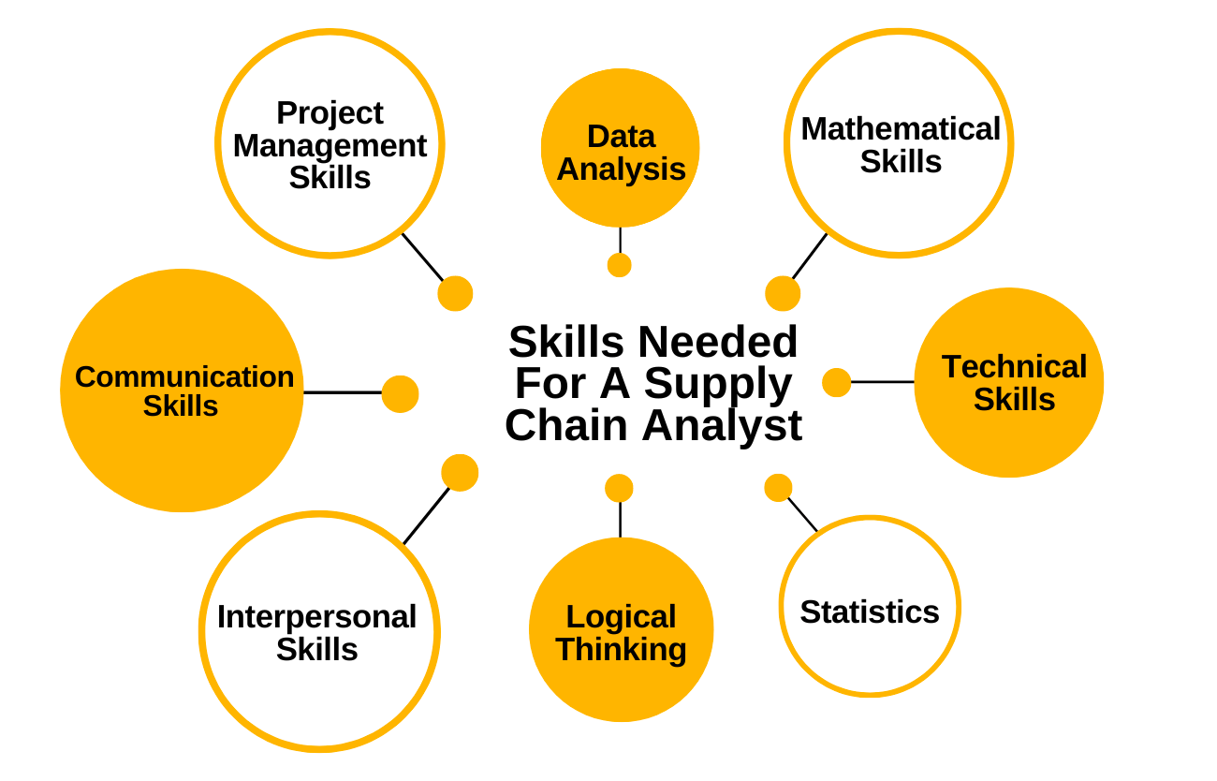

✅ A skilled data analyst transforms data into a competitive advantage, helping businesses respond faster, plan smarter, and operate leaner.

**🚧 Challenges**

* **Data Integration**: Siloed systems make it hard to unify data across departments and suppliers.
* **Data Quality**: Inaccurate, outdated, or unstructured data can lead to poor decisions.
* **Skilled Talent**: There’s a gap in professionals skilled in both supply chain and data science.

**🔮 The Future of Big Data in SCM**

* **AI + Big Data Fusion**: Combining machine learning with big data for smarter, faster decision-making.
* **Real-Time Dashboards**: Visual analytics that provide instant supply chain health status.
* **Sustainable SCM**: Using big data to track and reduce carbon footprints and promote ethical sourcing.

**✨ Conclusion**

Big data is no longer optional — it’s the backbone of efficient, resilient, and customer-centric supply chains. From demand forecasting to supplier management and real-time logistics, data analysts are at the heart of this transformation. Companies that adopt data-driven strategies today are better equipped to navigate uncertainty, reduce costs, and deliver exceptional value across the supply chain.